Activity Diagrams:
An Activity diagram is a variation of a special case of a state machine, in which the states are activities representing the performance of operations and the transitions are triggered by the completion of the operations. The purpose of Activity diagram is to provide a view of flows and what is going on inside a use case or among several classes.
Activities:
An activity represents the performance of some behavior in the workflow.
Transitions:
Transitions are used to show the passing of the flow of control from activity to activity. They are typically triggered by the completion of the behavior in the originating activity.
Decision Points:
When modeling the workflow of a system it is often necessary to show where the flow of control branches based on a decision point. The transitions from a decision point contain a guard condition, which is used to determine which path from the decision point is taken.
Synchronization Bars:
In a workflow there are typically some activities that may be done in parallel. A synchronization bar allows you to specify what activities may be done concurrently. Synchronization bars are also used to show joins in the workflow.
Swim lanes:
Swim lanes may be used to partition an activity diagram.
Initial and Final Activities:
There are special symbols that are used to show the starting and final activities in a workflow. The starting activity is shown using a solid filled circle and the final activities are shown using a bull's eye.

Registration Diagram:
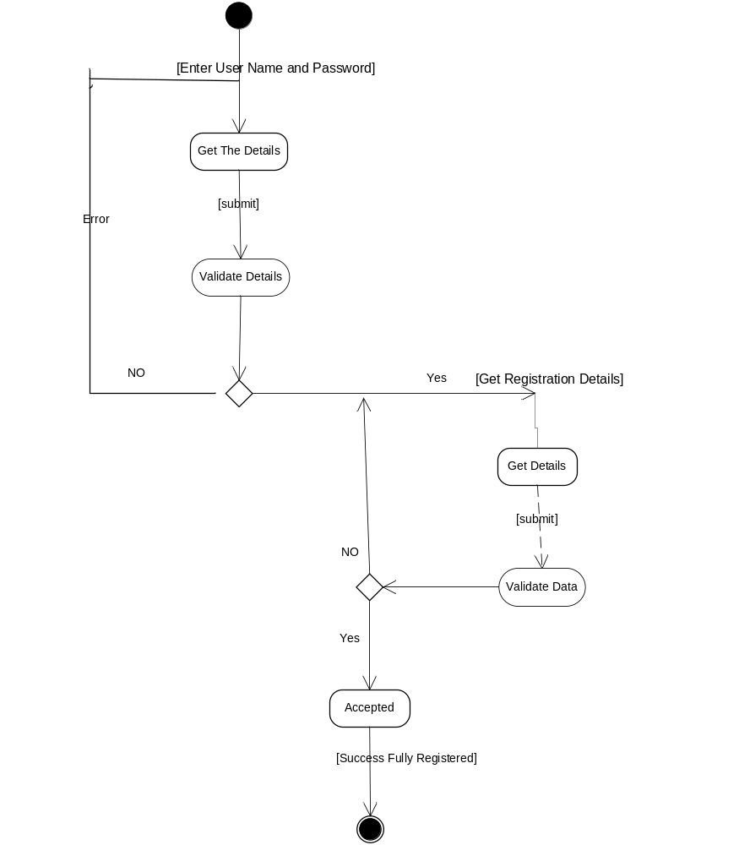
Login Activity Diagram:
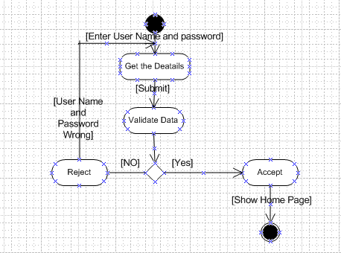
Admin Activity Diagram
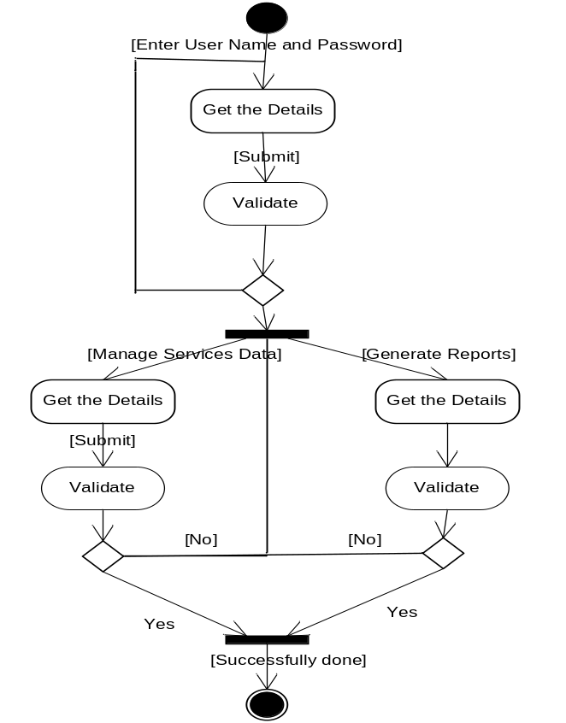
User Activity Diagram:
